BCIS 3610 – Tableau  
Created by: Kashif Saeed

# Module 1 – Getting Familiar with Tableau

* Tableau Products
  + Tableau Desktop
    - Used for client authoring
  + Tableau Server
    - Used for viewing/sharing content
  + Tableau Reader
    - Free offline viewer
  + Tableau Public
    - Free online public version
  + Tableau Public Premium
    - Hosted service for public websites
* Application Terminology
  + Cards (Pages, Filters, Marks)
  + Shelves (Columns, Rows, Colors, Labels etc.)
  + Data Window
  + View window
* Measures vs. Dimensions
  + Measures are represented by a green sign whereas dimensions are represented by blue sign
* Discrete or Continuous

Blue ‘Abc’ icon next to the field indicates that the field is discrete.  
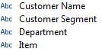

Green # icon indicates that the field is continuous.  
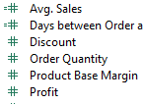

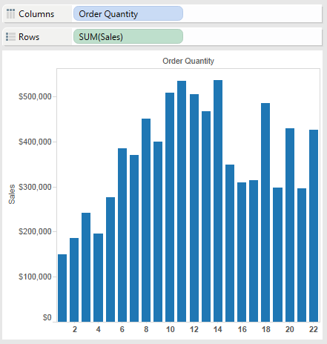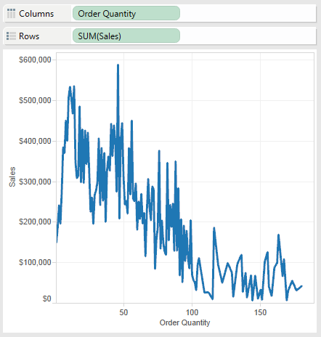

Discrete fields show as Blue rectangles and Continuous fields as Green on the shelves.

# Activity – Exploring Tableau and the Data

**Objectives:**

* Connect to an Excel source
* Create a Workbook
* Explore different options creating worksheet

**Steps:**

1. Create a new workbook. Connect to data and use MS Excel and point to folder containing **Training Superstore Sales.xls  
   Use the Orders sheet only.**
2. Create a view by dragging the following elements from the data window to specified locations:
   1. Drag Sales to Columns
   2. Drag Department to Rows
   3. Drag Category to Rows to the right of Departments
   4. Drag Profit to Color on the Mark card  
        
      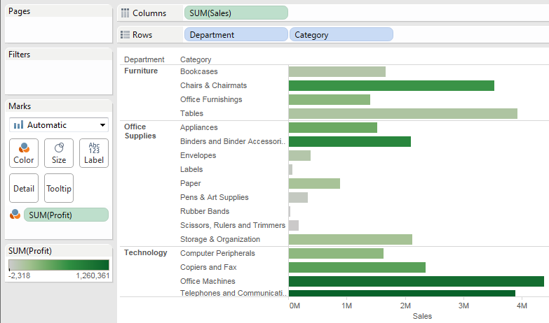
3. Format the view as follows:
   1. Sort the bars for Category by Sales in descending order by clicking on the sort icon on the sales axis  
        
      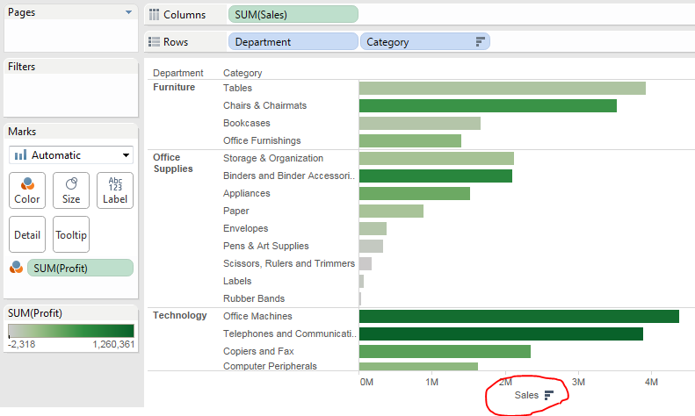
   2. Rename the Worksheet tab “Sales by Category” by double-clicking on the sheet tab   
      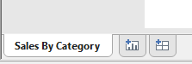
   3. Show the title by choosing from the Toolbar: Worksheet > Show title
   4. Double-click on the title to edit, and add the second line “Color represents Profit”  
      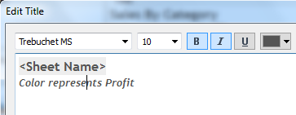  
        
      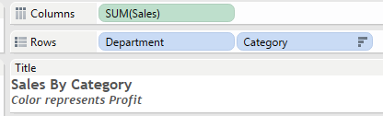
   5. Show the caption by checking on Worksheet > Show Caption  
        
      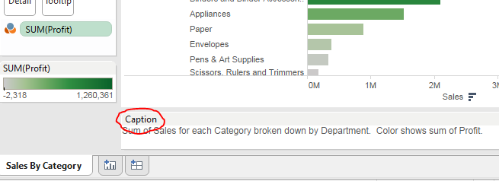
   6. Save the workbook as “1 – Getting Started”

# Module 2 – Working with your Data

## 2.1 Filtering Data

* Filters can be applied at Data Source or Worksheet level
* Filter options vary by field type (Dimensions, Measures, Date)
* Use of Quick filters for interactivity

# Activity – Filtering

**Objectives:** Explore how filters change the view and work when applied on different fields.

**Steps:**

1. Connect to the Training Superstore Sales.xls data source. Connect to the Orders worksheet using a live connection.
2. Create a heat map by completing the following steps:
3. Drag Customer Segment to Columns
4. Drag Category to Rows
5. Drag Sales to Size in the Marks card
6. Drag Profit to Color in the Marks card
7. Click on Size on the Marks card and use slider to increase the size of the marks  
     
   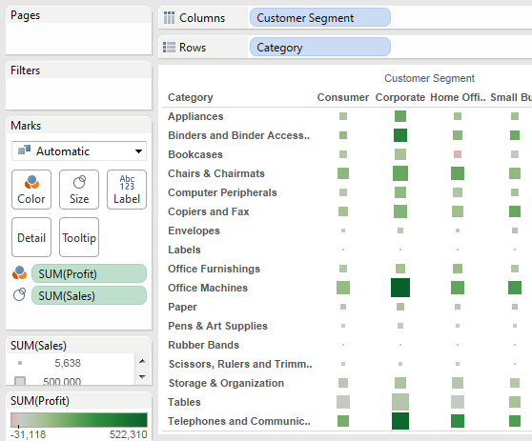
8. Create a Quick filter on Region
   1. Drag the Region field to Filter shelf and select Central and East as selected values
   2. Right-click Region on the Filter shelf and choose ‘Show Quick Filter’
9. Add a Quick filter for Year by right-clicking on the Order Date and choosing ‘Show Quick Filter’. Change the filter display to a single value list.
10. Add a Quick filter for Profit and set the range from -2k to 20k
11. Name the worksheet as Filters
12. Add Caption and Title
13. Choose the menu Worksheet > Tooltip to edit the tooltip
14. Save the Workbook as ‘2 – Working with Data’

## 2.2 Grouping

A group is a group of dimension objects that have been combined into higher level categories. For example, you can combine several smaller states together into a larger grouping called a ‘Region’. Or bring several products together into a product category.

Creating Groups:

* Control Click several dimensions in View window and then click the Group icon. OR
* Select a dimension on the Data window, right click and select Create Group.

## 2.3 Hierarchies

Hierarchies are a leveled grouping of dimensions what provide a path over which data is summarized. Example Geographic Hierarchy 🡪 Country, Region, State, City, Zip

Hierarchies provide a drill path.

To build hierarchies, drag the Child fields on to the Parent field in the Data window. OR

Select several fields in the Data window, right click and select ‘Create hierarchy’.

# Activity – Grouping and Hierarchy

**Objectives:** Create Logical Group and Hierarchy.

**Steps:**

1. Continue with the Workbook used in the previous activity. Add a new worksheet.
2. Drag Sales to the Columns shelf.
3. Drag Category to the Rows shelf.
4. Sort by Sales in descending order by clicking on the Sort button on Sales axis.  
     
   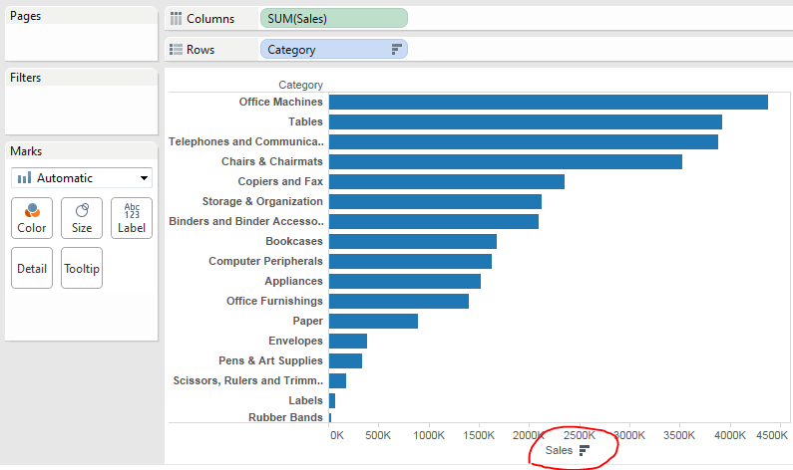
5. Create a group from Category:
   1. Using control-click, select the labels from the following Categories: Envelopes, Pens& Art Supplies, ‘Scissors, Rulers and Trimmers’, Labels, and Rubber Bands.  
        
      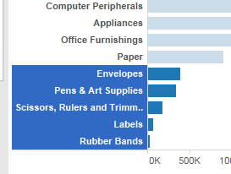
   2. Once selected, click on the paper clip icon
   3. Notice the values are grouped into a new dimension called Category (group)  
        
      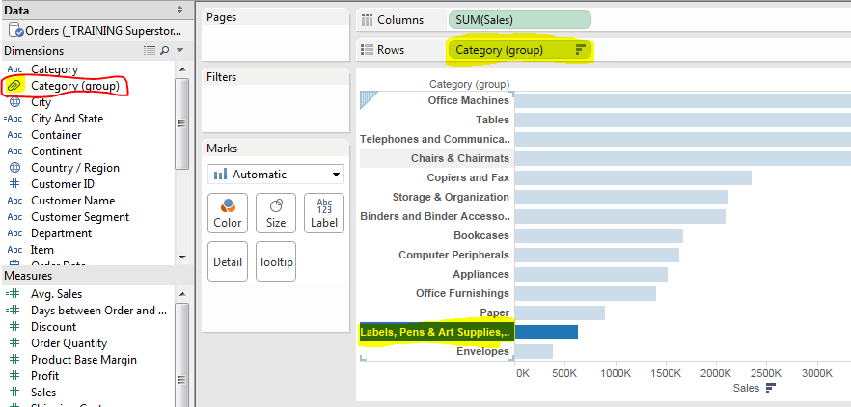
6. In the graphical View, rename the label for the new member to “Desk Supplies” by right clicking on the label and selecting ‘Edit Alias’.  
     
   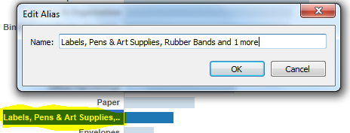
7. Create a Product Hierarchy
   1. In the data window, drag the dimension Category (group) onto the Department dimension.
   2. Name the new hierarchy “Product”
   3. Continue dragging items into the hierarchy Product 🡪 Department, Category(group), Category, Item  
        
      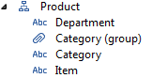
8. Drill into Category (group)
   1. From the view, hover over the label for Category (group) values until the + sign appears.
   2. Click on the + to drill down to the next level
   3. Re-sort the bars by clicking on the sort icon on the Sales axis. A new sort is added to the Category field.  
        
      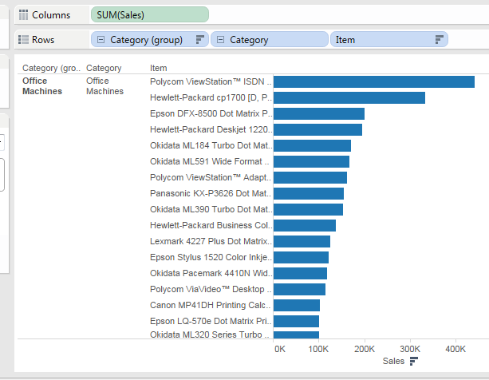
9. Edit the worksheet title to be “Category Grouping in a Hierarchy” and show the caption from the worksheet menu.
10. Save changes to the workbook.

## 2.4 Sets

Sets are custom fields you create based on existing dimensions, and are subsets of your data that meet certain conditions.

Think of Sets as Pre-defined conditions which you can use over and over again.

You can also create a new set by combining existing sets. This is called Combined Sets.

# Activity – Sets

**Objective:** Create a Set and explore using it.

**Steps:  
  
Create a Set for Top 50 Items by Sales**

1. Open the last saved workbook and add a new worksheet.
2. Move Sales to the Columns shelf.
3. Move ‘Items’ to the Rows shelf.
4. Sort ‘Items’ in descending order by Sales.
5. Create a Set called ‘Top Selling Products’
   1. In the data window, right-click ‘**Item’** and select ‘Create set’.
   2. Ensure ‘Use All’ is selected in the General tab.  
        
      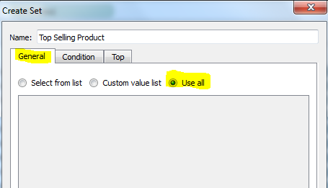
   3. In the Top tab, create the set for Top 50 Items by Sum of Sales (use By Field).  
        
      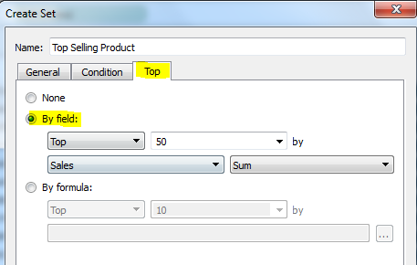
   4. Once created, the set will appear in the bottom left as shown.  
        
      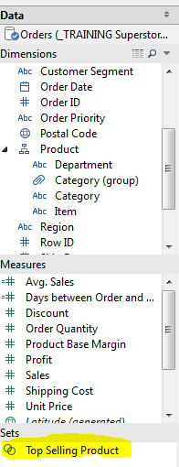
6. Filter the view with the Top Selling Products by dragging the set to the Filter shelf.   
     
   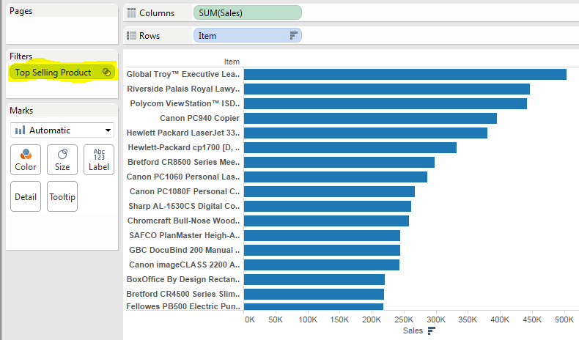
7. Edit the worksheet title to be ‘Top Selling Products’.
8. Show the Caption and the title.
9. Save changes to the Workbook.  
     
   **Create a Set for 50 Least Profitable Products**
10. Add a new Worksheet and move Profit to Columns and Items to Rows.
11. Sort Item in ascending order by Profit.
12. Create a set called ‘Least Profitable Products’.
    1. Highlight **Item** in the data window, right-click and select ‘Create Set’.
    2. Ensure ‘Use All’ is selected in the General tab  
         
       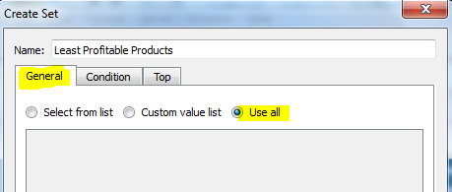
    3. In the Top tab, create the set for bottom 50 Items by Sum of Profit.  
         
       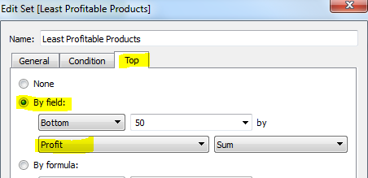
13. Filter the view by dragging the set to the filter shelf.  
      
    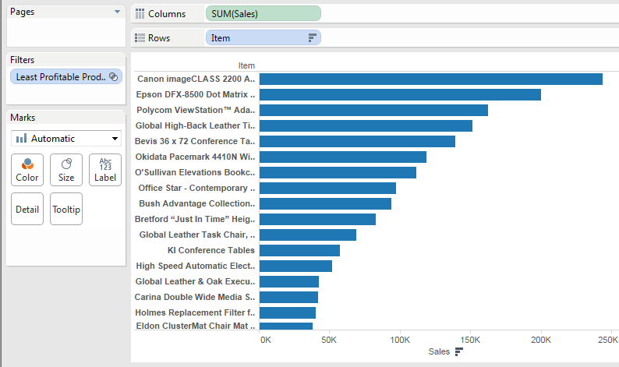
14. Edit the Worksheet title to be ‘Least Profitable Products’.
15. Show the Caption and the title.
16. Save changes to the workbook.

**Combined Set – High Sales and Low Profits**

1. Add a new worksheet to the workbook and create a scatter plot to show the correlation of Sales and Profitability:
   1. Add Sales to Columns shelf
   2. Add Profit to Row Shelf
   3. Add Item to Detail on the Marks card
2. Create a Combined set called “High Sales and Low Profits” made up of intersection between the Items that are in both sets created.
   1. Control-click both the sets, then right-click and select ‘Create Combined Set’
   2. Name the set ‘High Sales and Low Profit’ and select the option for the Shared Member in both Sets and click OK.  
        
      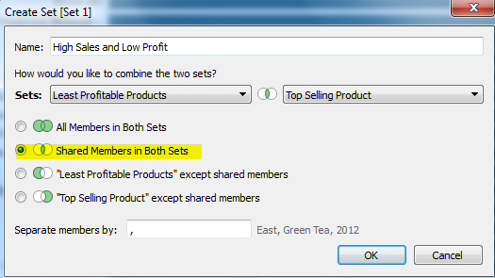
3. Drag the set to Color on the Marks card, and then drag it again to Size to visually indicate where the intersection occurs.
4. To edit the color or size, choose ‘Edit’ from the drop-down caret of the legend.
5. Edit the worksheet to be titled ‘Sales and Profitability’ and show the caption and title.
6. Save changes to the workbook.  
     
   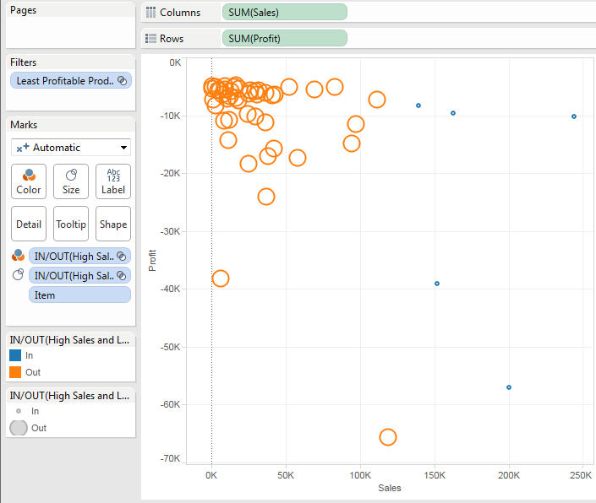

# Module 3 – Working with Dates

In this module, we will learn the following concepts:

* Date fields have automatic date hierarchies
* You have the ability to choose any level of the date hierarchy
* Reordering of Date hierarchy is allowed and results in very interesting analysis
* The ability to place different date parts on different shelves
* Discrete vs. Continuous dates

## Automatic Date Hierarchies

* Tableau creates an automatic date hierarchy for the Date fields.
* The date parts in the date hierarchy depend upon the data in the source system. For example, you may not have timestamp in the source system for the date field.
* When you bring a date field to a shelf, Tableau automatically uses highest date level as the default and places a + sign on the highest date level.
* Tableau determines the highest level by analyzing the values in the date field. For example, if the values include multiple Years, then Tableau makes Year as the highest level. However, if the values include only 1 year, then Tableau makes Quarter or Month as the default level.  
    
  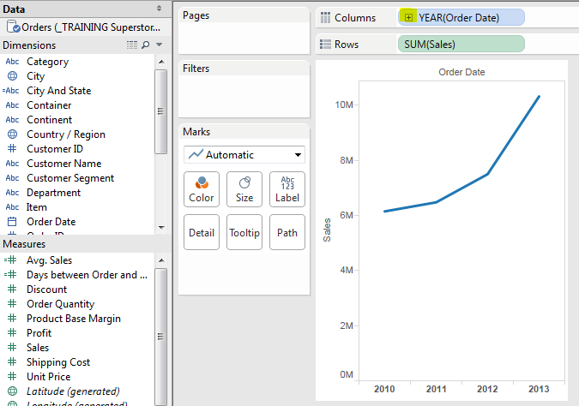

Change the date level using the field context menu on the shelf.  
  
  
Reordering the Date Hierarchy in the Shelf

1. Bring the Order Date to Columns Shelf
2. Bring the Sales object to Row Shelf
3. Expand the Year object to include Quarter in the Columns Shelf
4. Move the Quarter object before the Year object in the Columns Shelf
5. Notice how the view compares Quarters for different years.

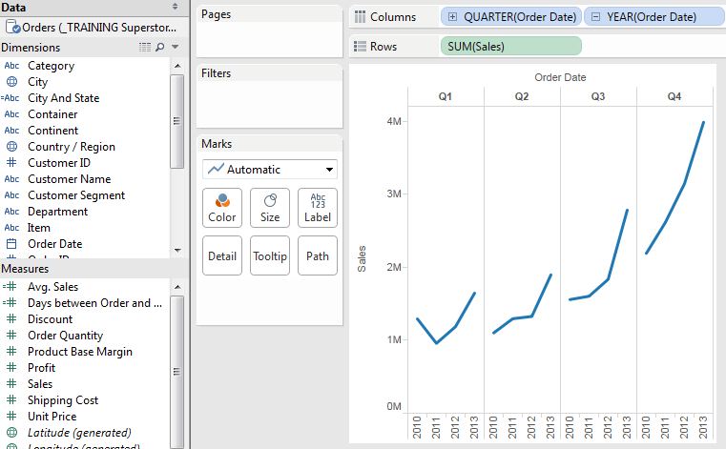

## Different Date Parts on Different Shelves

Bring the Quarter field in the example above to the Rows Shelf. Notice how the view changes.

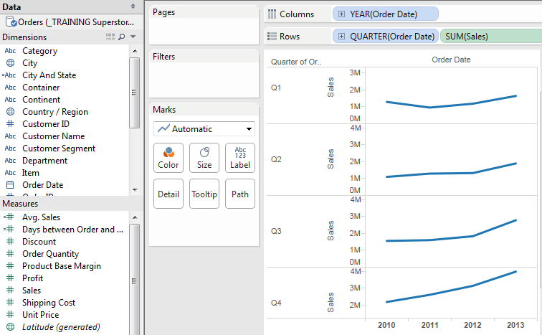

## Discrete vs. Continuous Date Parts

By default, date dimensions are discrete and Tableau shows them as discrete when placed on a shelf.

Place Quarter object on the Columns shelf and Sales object on the Row shelf.  
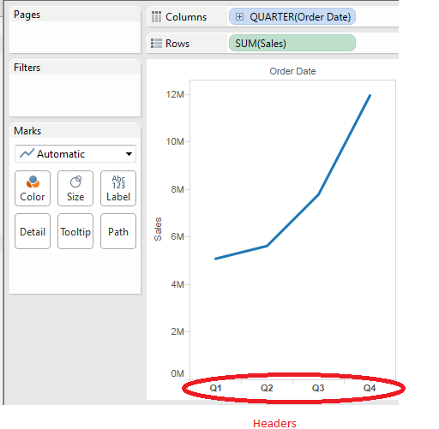  
Discrete date parts create Headers for the field members and only represent date ranges that contain data.

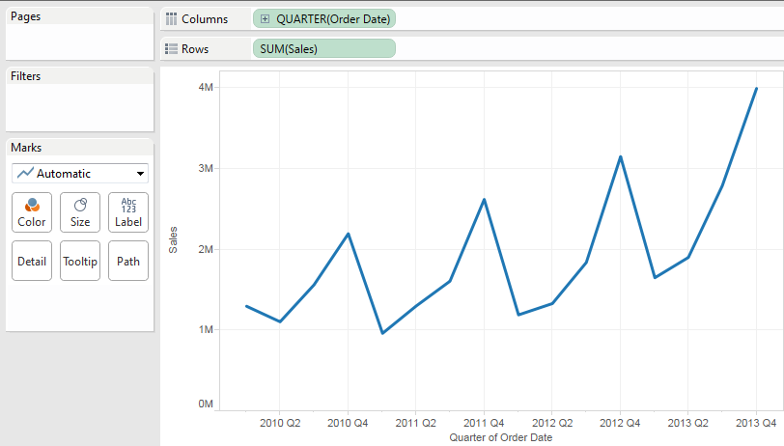

Continuous date values create an axis range for all possible dates within a range.

## Activity – Working with Dates

**Objective:** To display meaningful trend analysis using Dates.

**Steps:**

1. Create a new workbook and connect to Training SuperStore Sales and the Order table.
2. Create a view using Discrete dates:
   1. From measures, drag Sales to Rows
   2. From dimensions, drag Order Date to columns
   3. Drill from Year to Quarter and then to Month level.
   4. Rename the worksheet as “Discrete dates”
   5. Add a Caption and Title.
   6. Save the Workbook as ‘Working with Dates’
3. Create a view with Continuous dates:
   1. Duplicate the Discrete Dates worksheet
   2. In the new worksheet, bring the hierarchy back to the Year level by clicking on the minus sign on Order Date
   3. Right click on the Order Date field and select Continuous Year option. Note that the field turns green indicating that it is now Continuous.
   4. Notice how drilling on the Continuous field does not keep all levels on the shelf and hence there is no Minus sign to drill back up.
   5. Rename the worksheet “Continuous Dates” and save the workbook.

# Measure Values and Measure Names

Measure Values field appear at the bottom of the Measure area of the Data Window and contains all the measures of your data source collected into one field. The Measure Names field always appears at the bottom of the Dimensions area and contains all the names of the measures collected into a single dimension.

Used for: Multiple measures in data views

Common Uses:  
- Combining more than one measure on same axis  
- Creating cross tabs with more than one measure represented as text

## Activity – Combined Axis Chart

**Objective:** Create a view with a combined axis using Measure Names and Measure Values

**Steps:**

1. Create a new workbook and connect to Training SuperSales.
2. Create a view:
   1. From Measures, drag Sales to Rows
   2. From Dimensions, drag Customer Segment to Columns
   3. From Dimensions, drag Department to Rows
   4. From Measures, drag Profit to the existing Sales axis to create a combined axis view. Drop Profit when the mouse icon changes to a double ruler.
   5. The view now shows a single value axis.
3. Differentiate the bar color by dragging Measure Names to Color on Marks card.
4. Format the view:
   1. Right click on the Y-axis and edit the axis title to “Dollars”
   2. Right click on the header for Furniture in the view and rotate the labels for Furniture, Office Supplies, and Technology
   3. From the Analysis drop down, choose ‘Table Layout’ > and un-check ‘Show field labels for rows’ and ‘Show field labels for Columns’.
   4. Show the title and caption.
   5. Save the worksheet as “Measure Name and Value”.

# Module 4 – Latitude and Longitude

Tableau automatically creates Latitude and Longitude fields which can be used in the maps.  
Tableau geocodes at the following levels:  
  
- Country (Names, FIPS 10, 2 or 3 character ISO)  
- State/Province (Abbreviations and Names)  
- City (Names with population greater than 15,000)  
- County (Names – U.S. Only)  
- Zip Code/Postcode (United States, France, Germany, UK, Canada, Australia, and New Zealand)

## Activity – Geographic Mapping

**Objectives:** Use Tableau’s mapping functionality to display data geographically.

**Steps:**

1. Open the workbook from previous exercises. Add a new worksheet and name it ‘Geographic Map’.
2. Control-click the Country and Sales fields in the data window.
3. Click the Symbol Map option in the Show Me window.  
     
   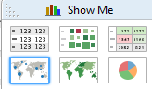
4. Click on Color in the Marks card to access settings. Change the transparency to 50% and add a black border to the circle marks.
5. Click on the Size in the Marks card to access settings. Increase the mark size.
6. Add a Title and Caption.
7. Duplicate worksheet and change the graph type to ‘Filled Maps’ from the Show Me window.
8. Save the workbook.

## Activity – Tree Map

**Objectives:** Create a tree map and customize it.

**Steps:**

1. Insert a new worksheet in the workbook and name it Tree Map.
2. Bring the Country/Region field to the Filter Card and filter the worksheet to United States only.
3. Control Click the State and Sales fields in the Data Window and select Tree Map from the Show Me window.
4. Bring the Profit field to the Color shelf in the Marks Card.
5. Bring the Sales field to the Label shelf in the Marks Card.
6. Edit the Label appearance and make the State name appear bold.
7. Edit the tooltip to include $ sign before the Sales and Profit numbers. Un-bold the Sales and Profit numbers.
8. Save the workbook.

# Module 5 – Building Dashboards

* A Dashboard is a collection of several worksheets
* One Workbook can have several worksheets and several Dashboards
* You can add worksheets, web pages, text, images etc. to your dashboards.
* Worksheets are connected to the dashboard(s) they are used in. Changes to worksheet(s) automatically reflect in the dashboards.
* Dashboard objects can be added as Tiled or Floating. Tiled objects are arranged in a grid while floating objects can be layered on top of other objects.

## Activity – Building a Dashboard

**Objectives:** Create a Sales Dashboard and make a filter work across all views in the Dashboard.

**Steps:**

1. Create a new workbook and connect to Training Superstore Sales.
2. Create separate worksheets for different kinds of views as mentioned below.
   1. A Pie Chart
      1. Sales by ‘Customer Segment’
      2. Include Labels for Segment
      3. Name it Sales by Segment
      4. Show Title
   2. A Bar Chart
      1. Country/Region to Rows and Sales to Columns
      2. Color encoded by Profit
      3. Sorting Country/Region by Sales in descending order
      4. A Quick filter with a single value list for Continent
      5. Named Sales by Region
      6. Show Title
   3. A Scatter Plot
      1. Sales to Columns and Profit to Rows
      2. Customer Segment to Color
      3. Category to Detail
      4. Click Color to reduce transparency
      5. Click Size to make marks bigger
      6. Name ‘Plot of Sales’ and show title
3. Add a Dashboard sheet and name it Sales Dashboard
4. On the bottom left of the Dashboard, change the setting for size to “Laptop” and check show title  
     
   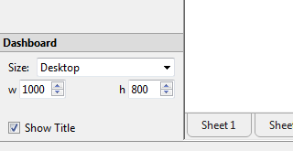
5. Drag three worksheets onto the dashboard space
6. For each Section, choose Fit > Entire View from the Drop down menu (click inside each window to get the drop-down)
7. Remove legend items that are not necessary
8. Apply the filter for Continent to entire dashboard by clicking on the caret menu on the filter, and choose Apply to Worksheets > All Using this Data Source
9. Make the Pie Chart interactive by clicking on the caret menu and choosing Use as Filter. Click on segment of Pie to test it.
10. Save the workbook.

## Using Actions to Make your Dashboards Interactive

* In addition to using Filters, you can use Actions to make your dashboards interactive.
* Actions can link to webpages or Tableau worksheets from your dashboard.
* There are three kinds of Actions: Highlight, Filter, and URL
* Action can be invoked by using: Hover, Select, and Menu (right-click menu)

## Activity – Building an Interactive Dashboard

1. Open the workbook created in previous exercise.
2. Add a new Worksheet and name it ‘Sales Map’
3. Control-click the Sales and Country/Region fields and select Filled Map from the Show Me window.
4. Show Title.
5. Add a new Dashboard to the workbook and name it “Action Dashboard”.
6. Add the sheets as shown:

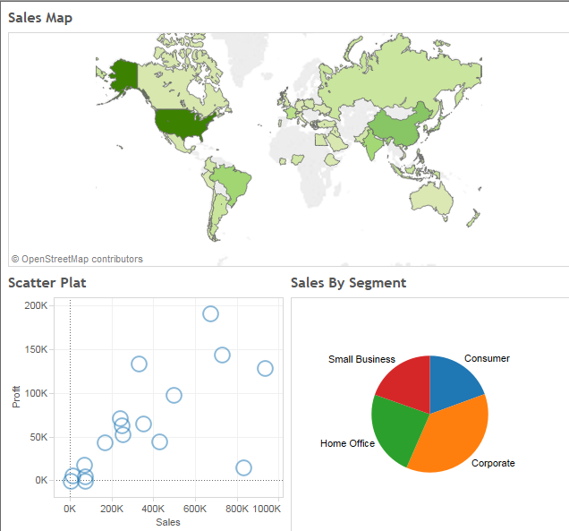

1. Add an action to the dashboard
   1. Go to Dashboard > Action and choose Add Action to add a Filter Action
   2. Name it ‘Map Filter’
   3. In the Source, select ‘Sales Map’ from Action Dashboard
   4. Run Action for ‘Select’
   5. Select all sheets under Target Sheets
   6. Select ‘Show All Values” for Clearing the Section

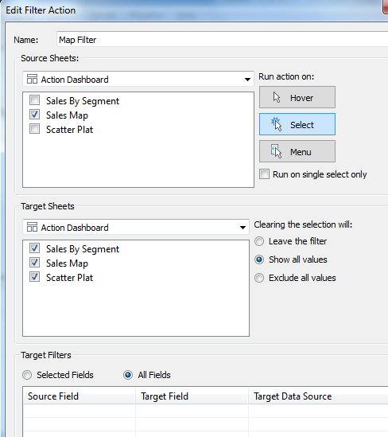

1. Test the Action filter.
2. Create another Filter as shown  
   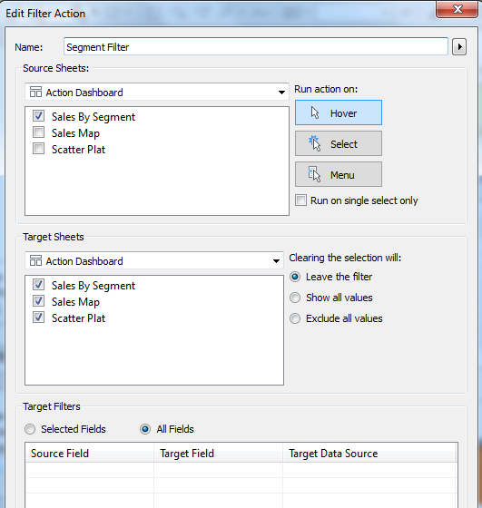
3. Test the filter.

# Module 6 – Data Blending

* Data Blending allows you to combine data from multiple data sources into a single visualization
* Data sources are combined automatically on fields with same names. If there are no fields with same names, you can manually combine the data sources.
* One Data source is primary and all other data sources are secondary
* The data source from which a field is first added to the view becomes the primary data source

## Activity – Data Blending

**Objective:** Display data from different data sources in a combined view.

**Steps:**

1. Open a new workbook and connect to Training Superstore Sales.xls
2. Create the following view:
   1. Sales to Columns
   2. Region to Rows
   3. Filter Country/Region to United States only
   4. Name the worksheet as ‘Data Blending’
3. Click Data > Connect to Data or Connect to Data icon in toolbar and connect to Sample – Coffee Chain.mdb.
4. Bring the Coffee Chain Query to the selected tables and click on Go to Workbook
5. Blend/Combine the data to define relationship between data sources
   1. Choose Data > Edit Relationships
   2. Select Orders (Training Superstore Sales.xls) as the Primary source and Coffee Chain and Coffee Chain as secondary data sources
   3. Change the Relationship type to Custom and click the Add button
   4. Choose Region from Primary and Market from Secondary
   5. Click OK and close
6. Right click on the Sales field from Coffee Chain data source in the Data Window and rename it as ‘Coffee Sales’
7. Drag Coffee Sales to the Sales Axis in the view to create a Combined Axis view.
8. Drag Measure Names from Rows to Color in the Marks Card to stack the measures.
9. Save the workbook.

## What’s Next?

Need more practice in Tableau?

Go to Tableau Public website and browse the gallery. You can download visualizations and sample data from the website.

<https://public.tableau.com/s/gallery>